VPC Firewall

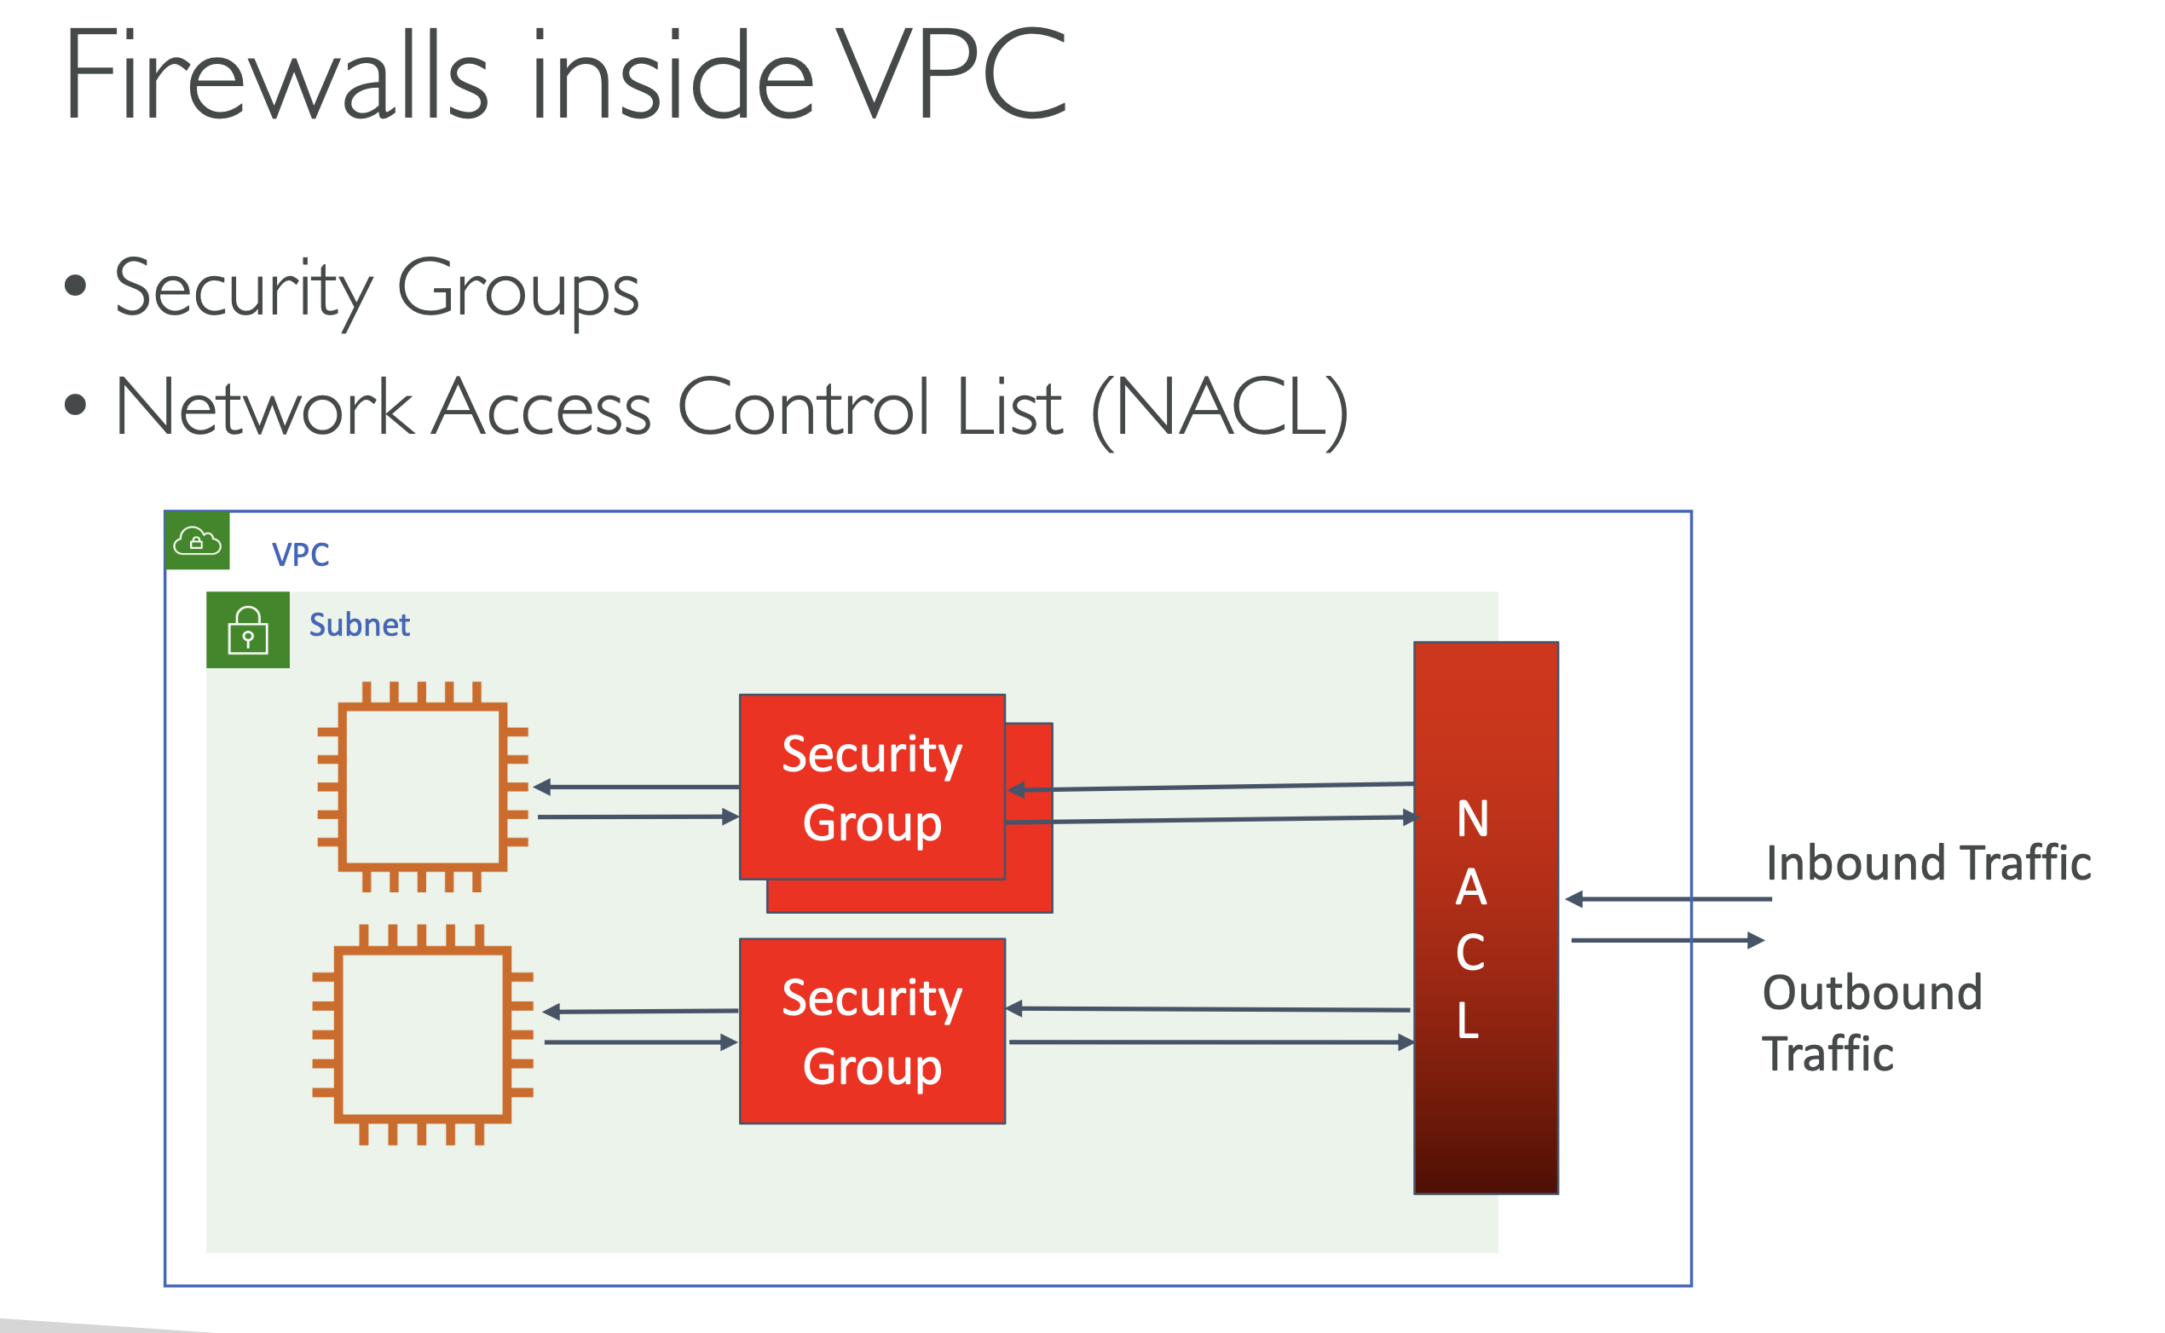

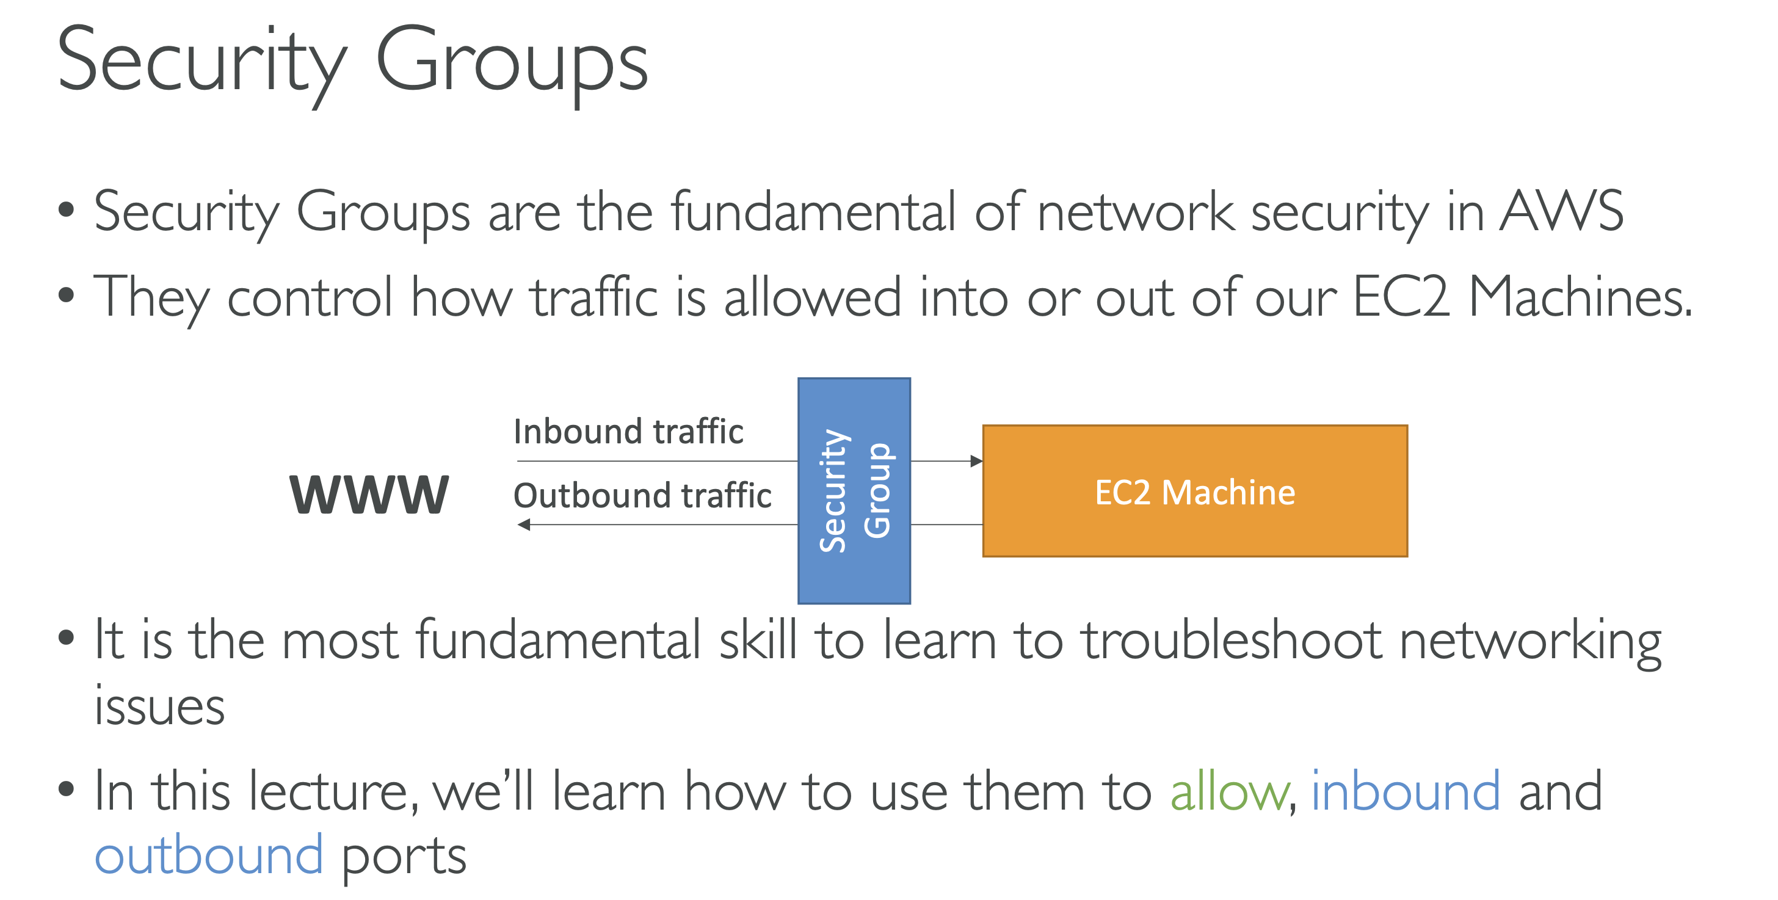

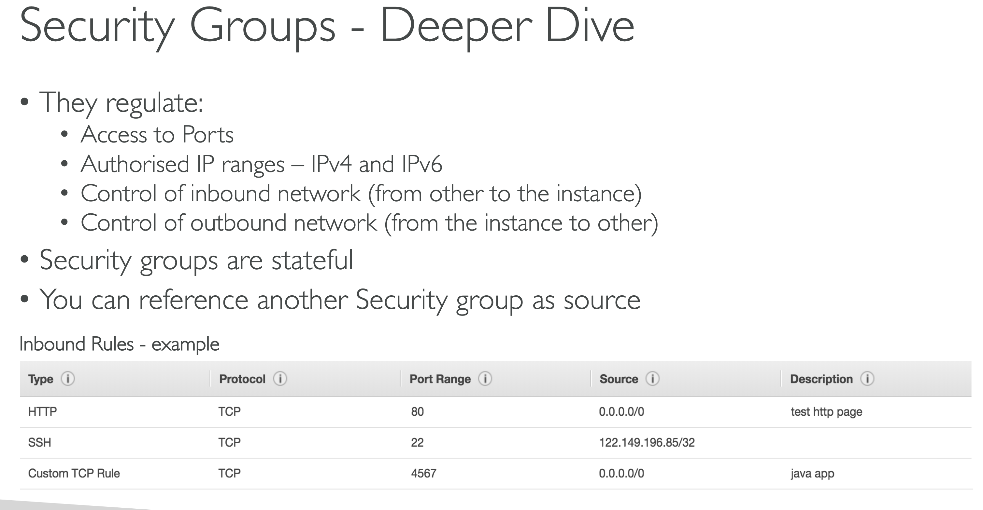

**Stateful** means that **AWS security groups automatically allow return traffic for any request that you permit**, without needing explicit rules.

**What this means in practice**

* If you allow **inbound traffic** (e.g., TCP 443)  
  👉 **Response traffic is automatically allowed**, even if outbound rules don’t explicitly allow it.
* If you allow **outbound traffic**  
  👉 **Return traffic is automatically allowed**, even if inbound rules don’t permit it.

By referencing the source security group in the inbound rule, I can allow access from all EC2 instances associated with that security group.

Network ACL:

Defined at Subnet level

Can be associated with one or more subnets

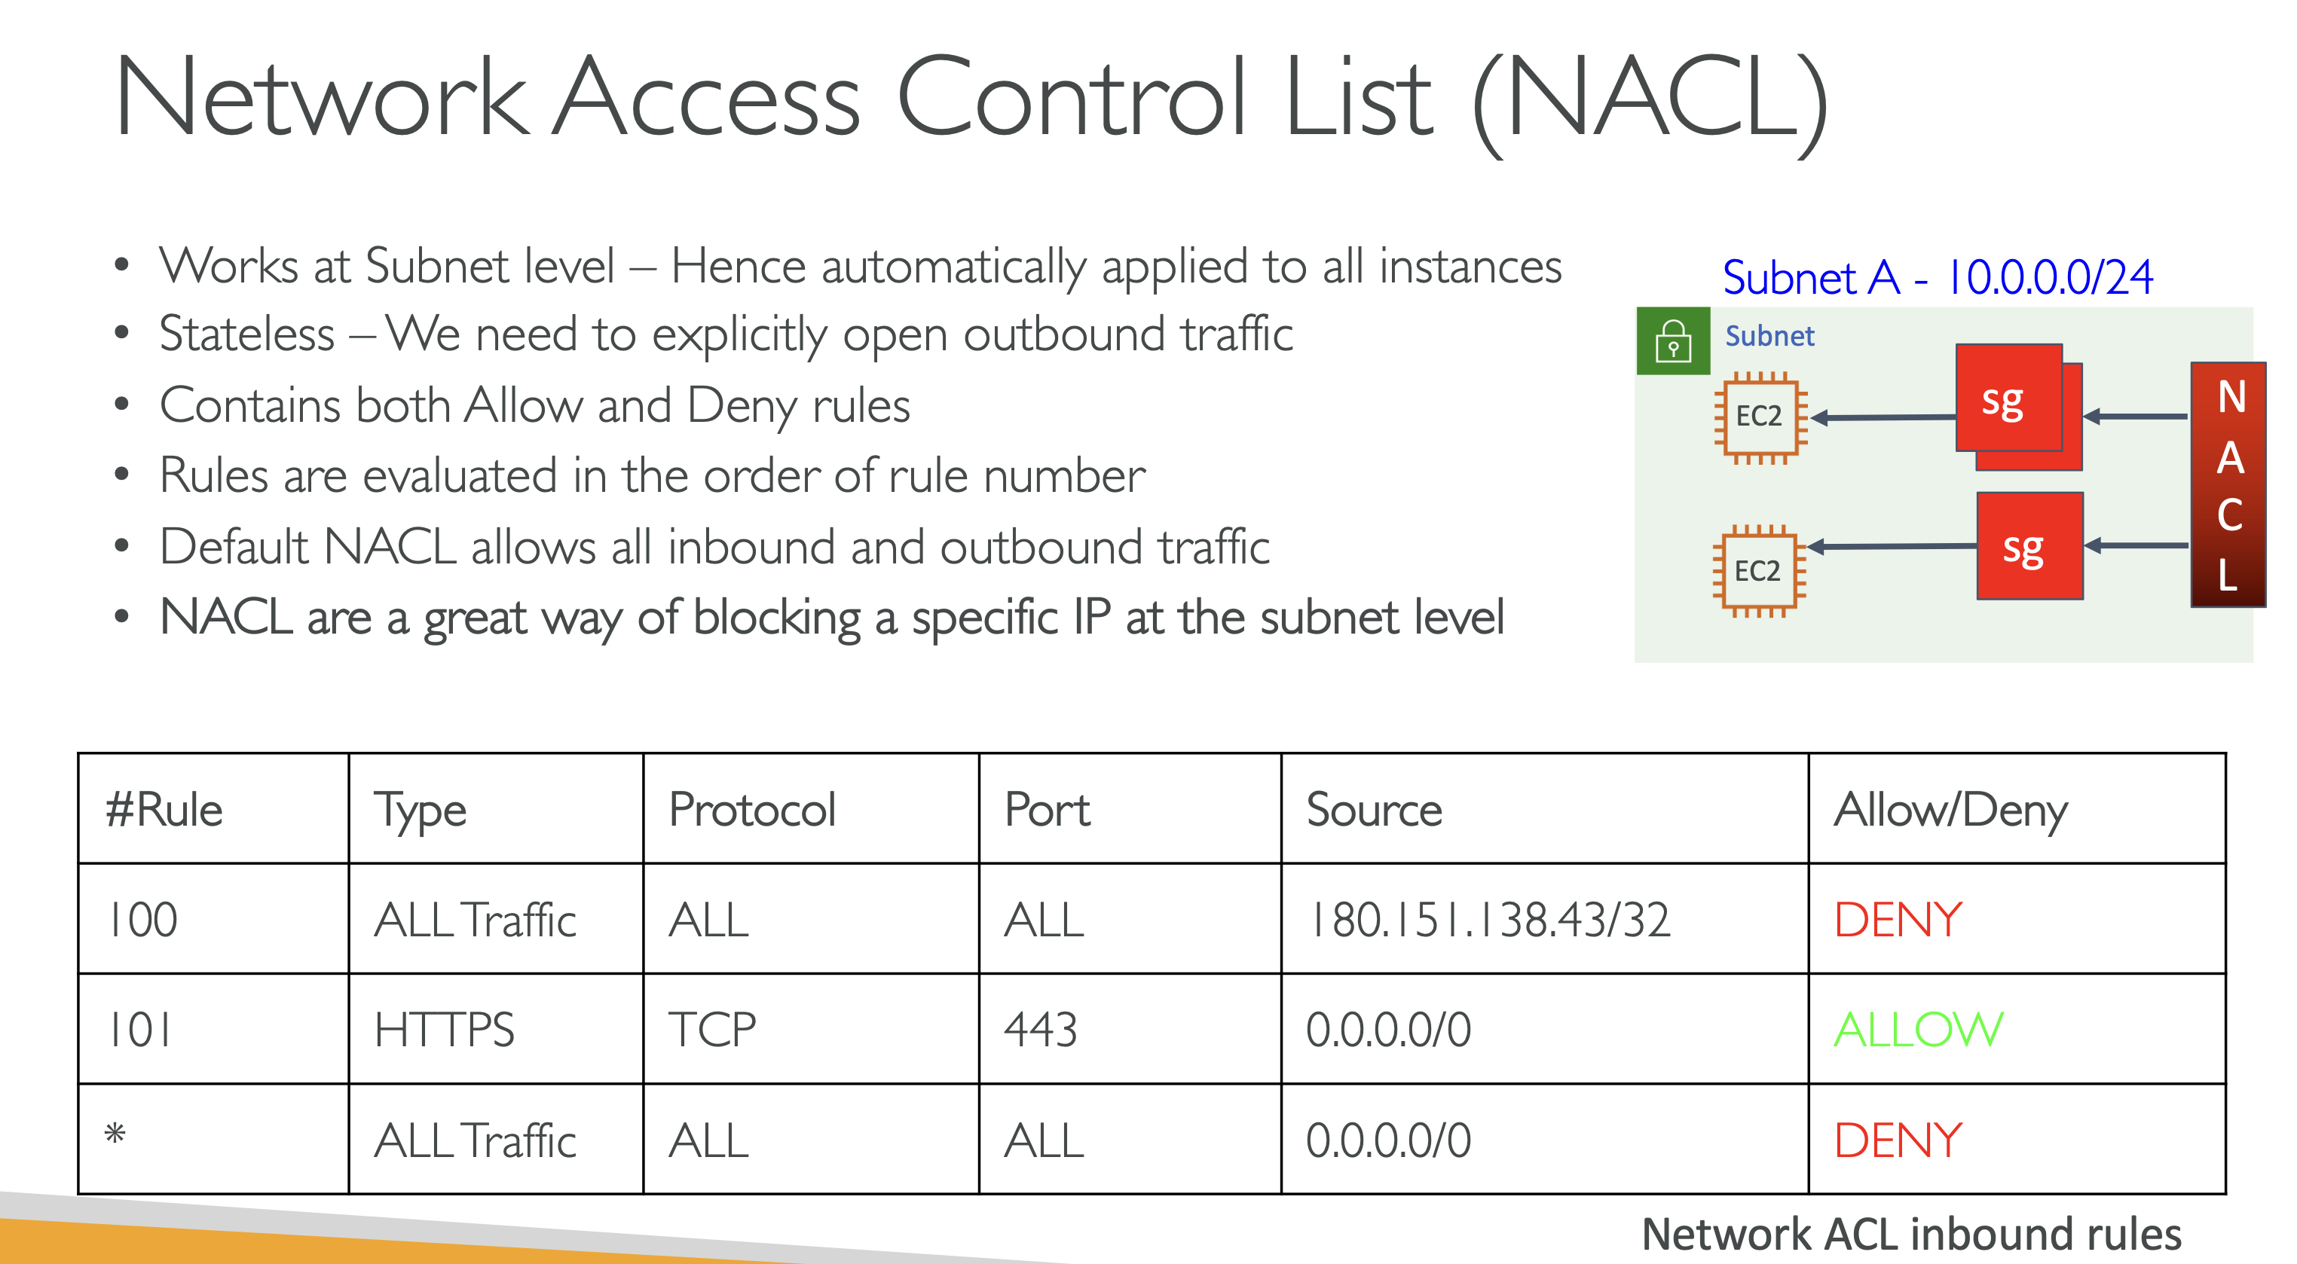

Default VPC:

Look for Main -> Yes entry for route table to know whether it is main VPC route table or custom route table for any subnet



